Kitchen Story

**Project objective:**

Kitchen Story is an e-commerce portal that lets people shop basic food items on their website. The website needs to have the following features:

* A search form in the home page to allow entry of the food items to be purchased by the customer.
* Based on item details entered, it will show available food items with price.
* Once a person selects an item to purchase, they will be redirected to the list of available items. In the next page, they are shown the complete breakout of the order and details of the payment to be made in the payment gateway. When payment is done, they are shown a confirmation page with details of the order.

**For the above features to work, there will be an admin backend with the following features:**

* Admin login page where admin can change password after login if he wants to
* A master list of food items available for purchase
* A functionality to add or remove food items

## Technologies:

* Java – Srping boot
* Angular
* MySql

DESCRIPTION:

In this project for providing necessary data a MySql Schema with the name “Kitchen-Story1” has been created. To Fetch data and to make it accessible for browser Java- spring boot technologies has been used to provide api endpoints. Finally, a Single Page Website has been created.

The Website works as follow:

Products [Home]: <http://localhost:4200/products>

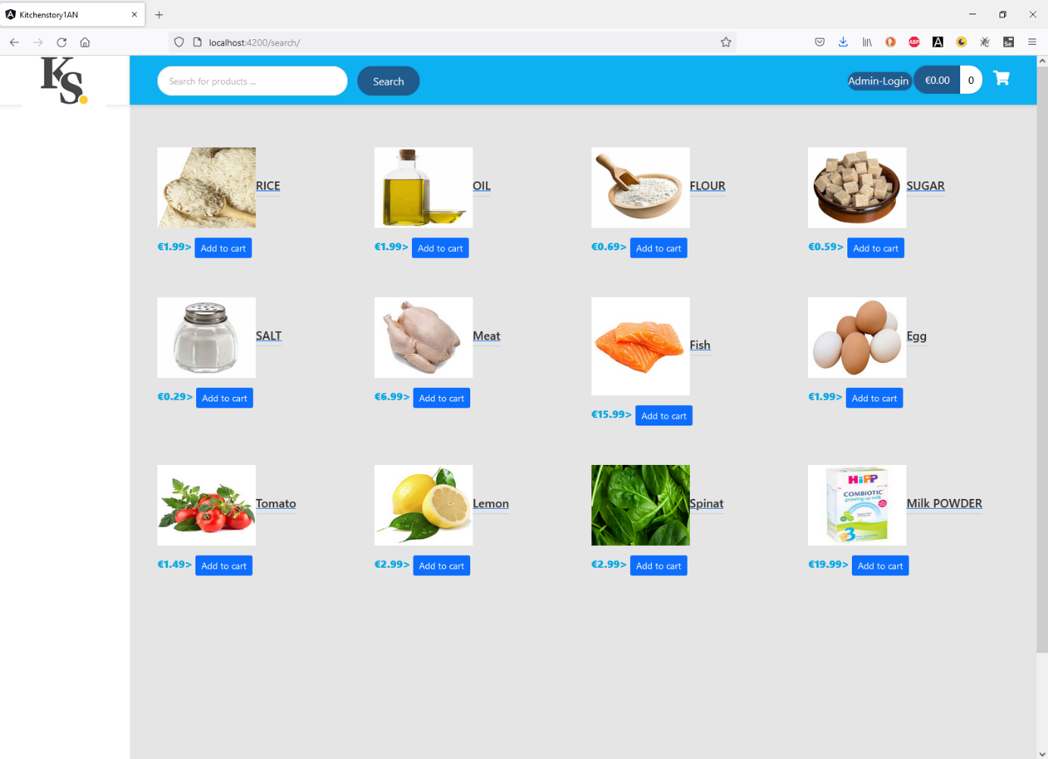

Figure 1:Home Page

Details of Product Item: [http://localhost:4200/products/{id}](http://localhost:4200/products/%7bid%7d)

Ein Bild, das Text enthält.

Figure 2-Item Details with amount and price

Upon clicking on a product name or on the image of the product will navigate to on that product’s detail which shows price and amount of the product in stock and an option to add the item to chart.

Adding Product item to Cart:

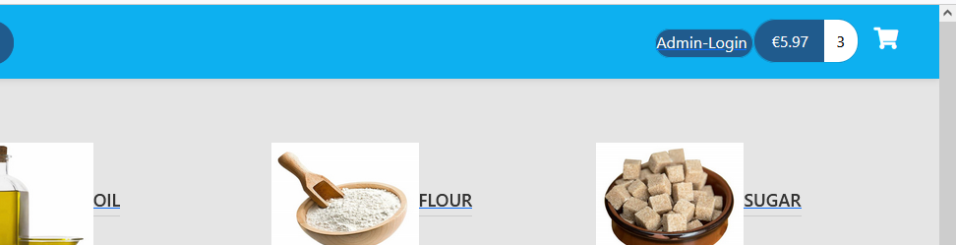

Figure 3-Adding Item to cart and showing the total price

A single click on the “Add to cart” will add item to the cart and for multiple clicks will add respective amounts of the item. Item logo will show the total price of the cart items.

Cart Details: <http://localhost:4200/cart-details>

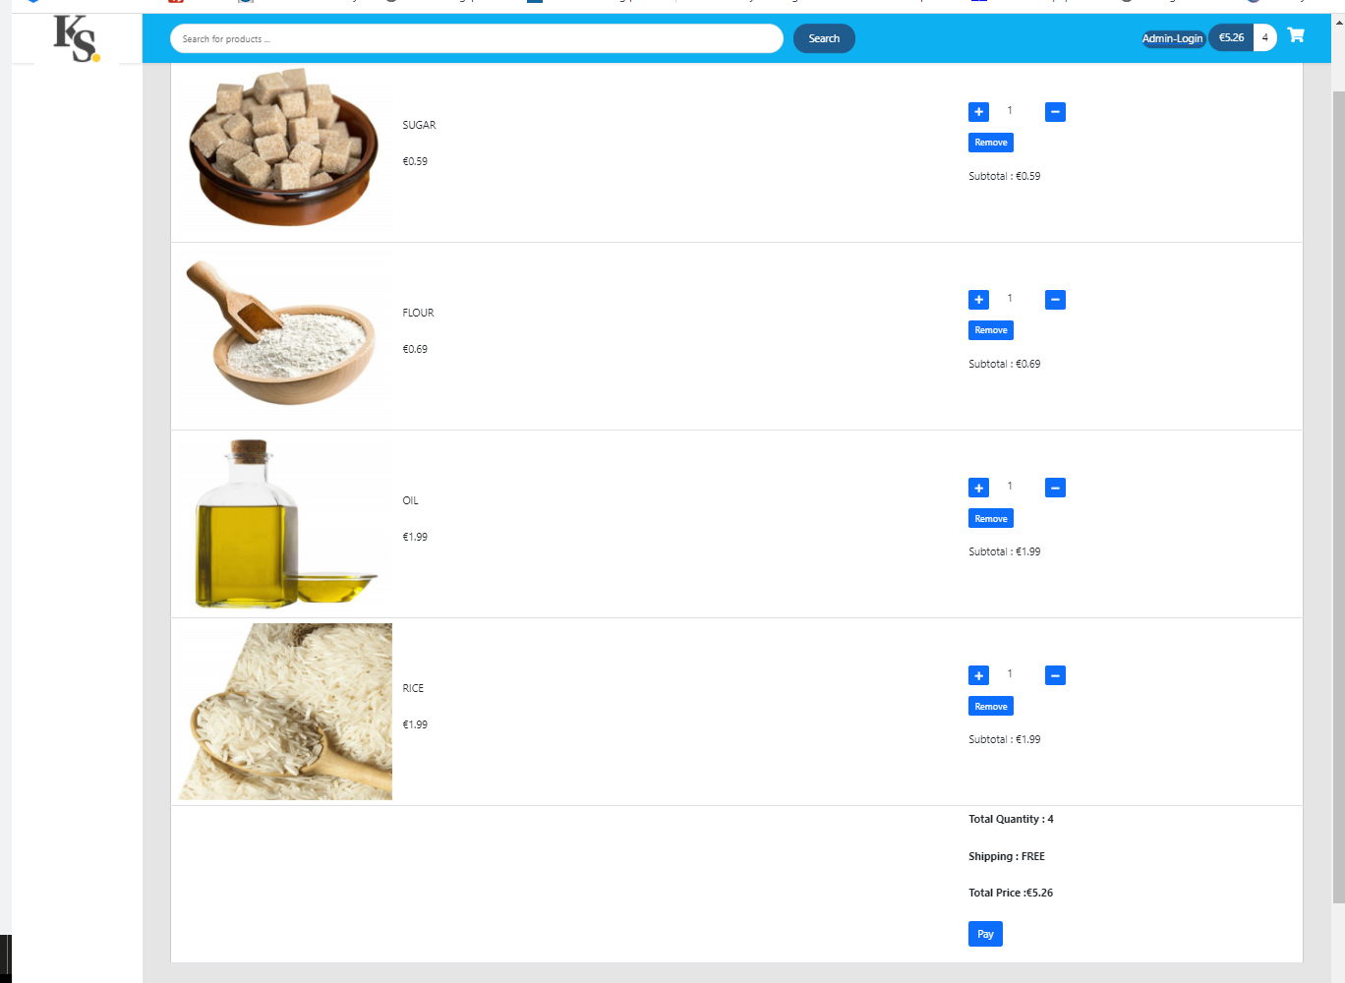

Figure 4-Cart details with the Breakdown of the quantity , unit price , subtotal price of an item and Total price

Cart details shows the breakdown List of the quantity of an item and its subtotal price with unit price .Item quantity can be increased or decreased with + and – button. There is also an option to remove the item with remove button.



Figure 5-Button to increase or decrease or the remove an item

Click on Pay Button will be worked as dummy payment.

Payment: <http://localhost:4200/payment>

Ein Bild, das Text enthält.

Following the dummy payment a conformation with “ Your order is confirmed!” will appear and a link to redirect to Products [Home] page.

Admin Login:

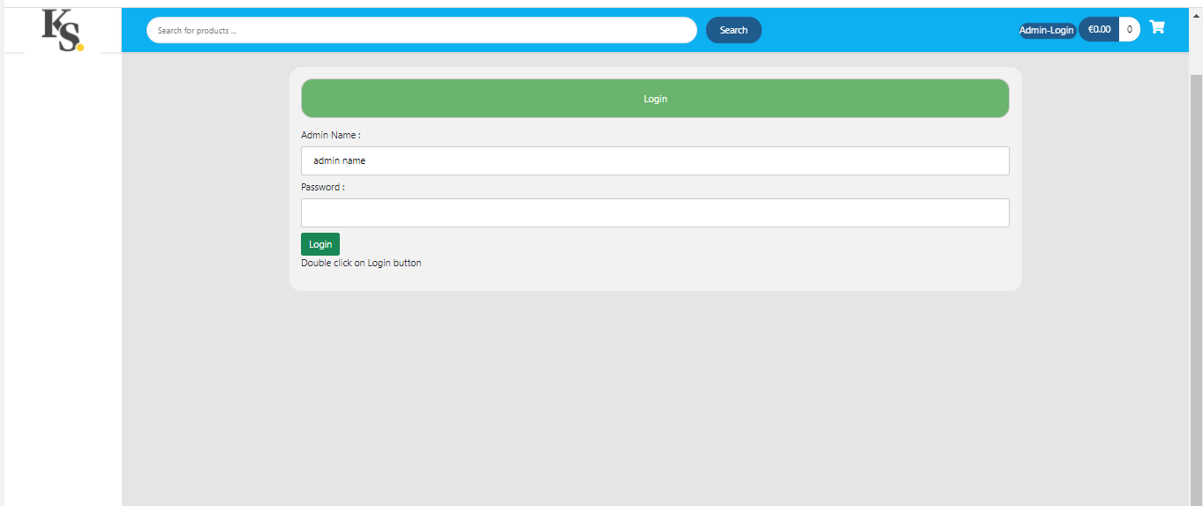

Figure 6-Login Window for Admin

Dashboard: Upon Logged in admin can reset password or can create, update or delete a product. 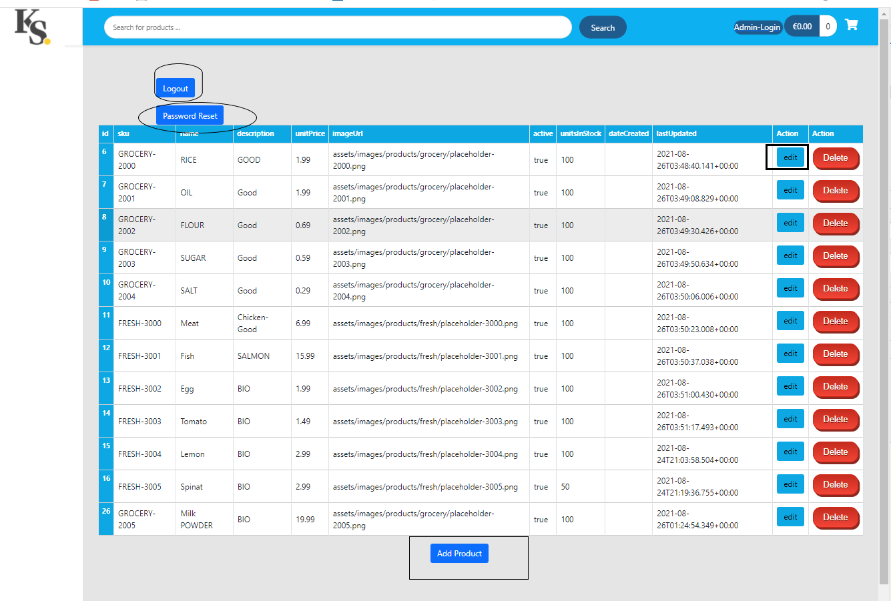

Figure -dashboard

Reset password:

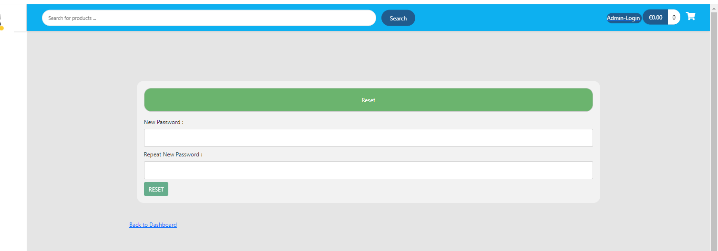

Figure 8-Reset Password

Update Product:

On click on update button update window will appear populating with the old information.

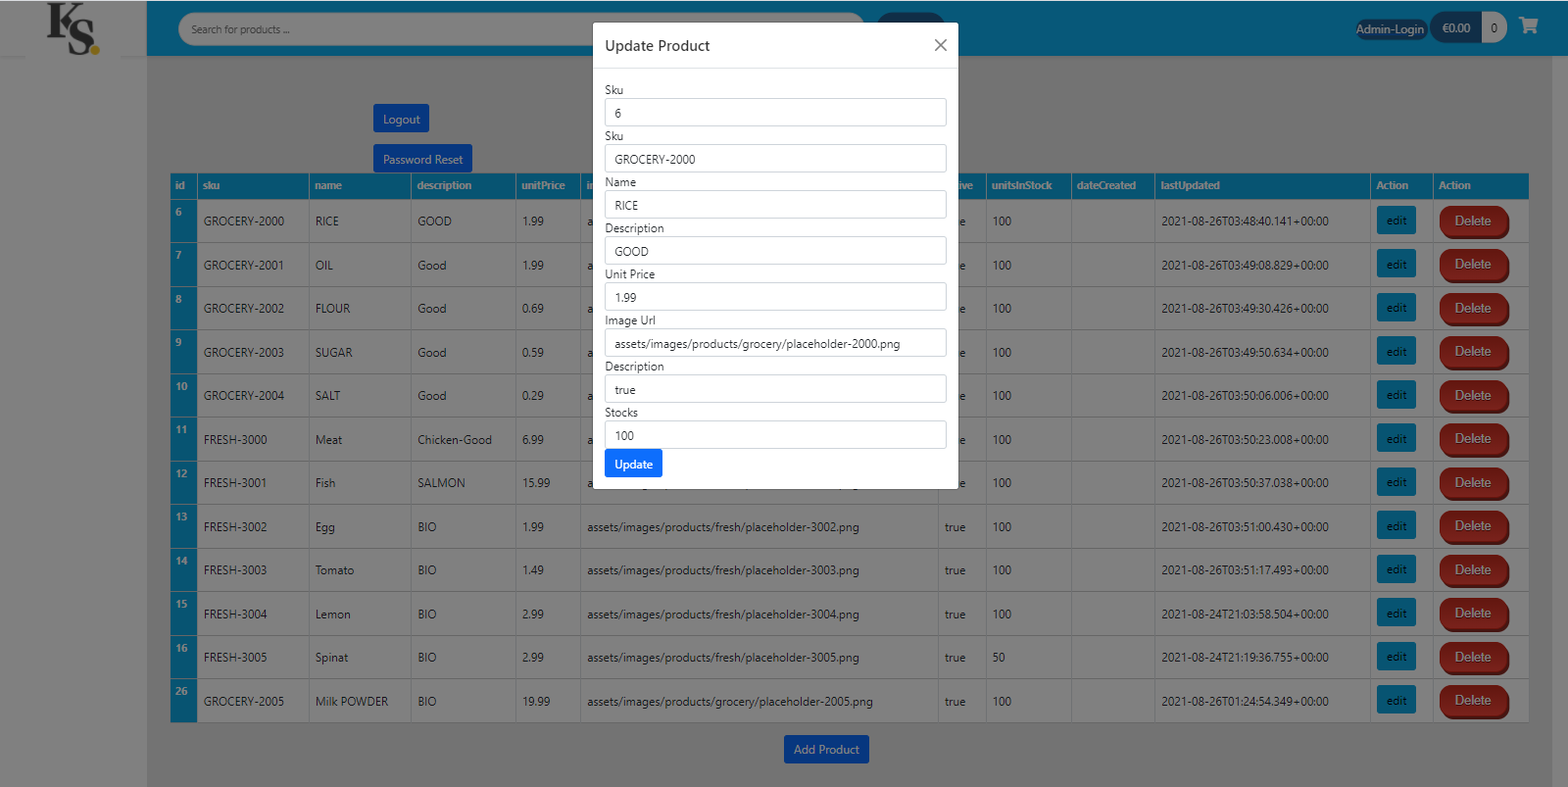

Figure -Product Update window

Create Product:

Ein Bild, das Tisch enthält.

Figure 10- Add Product window

Logout:

After logging out it will redirect to Login page again.